Computer Network | Types of area networks – LAN, MAN and WAN

The **Network** allows computers to **connect and communicate** with different computers via any medium. LAN, MAN and WAN are the three major types of the network designed to operate over the area they cover. There are some similarities and dissimilarities between them. One of the major differences is the geographical area they cover, i.e. **LAN** covers the smallest area; **MAN** covers an area larger than LAN and **WAN** comprises the largest of all.  
There are other types of Computer Networks also, like :

* PAN (Personal Area Network)
* SAN (Storage Area Network)
* EPN (Enterprise Private Network)
* VPN (Virtual Private Network)

**Local Area Network (LAN) –**  
LAN or Local Area Network connects network devices in such a way that personal computer and workstations can share data, tools and programs. The group of computers and devices are connected together by a switch, or stack of switches, using a private addressing scheme as defined by the TCP/IP protocol. Private addresses are unique in relation to other computers on the local network. Routers are found at the boundary of a LAN, connecting them to the larger WAN.

Data transmits at a very fast rate as the number of computers linked are limited. By definition, the connections must be high speed and relatively inexpensive hardware (Such as hubs, network adapters and Ethernet cables). LANs cover smaller geographical area (Size is limited to a few kilometers) and are privately owned. One can use it for an office building, home, hospital, schools, etc. LAN is easy to design and maintain. A Communication medium used for LAN has twisted pair cables and coaxial cables. It covers a short distance, and so the error and noise are minimized.

Early LAN’s had data rates in the 4 to 16 Mbps range. Today, speeds are normally 100 or 1000 Mbps. Propagation delay is very short in a LAN. The smallest LAN may only use two computers, while larger LANs can accommodate thousands of computers. A LAN typically relies mostly on wired connections for increased speed and security, but wireless connections can also be part of a LAN. The fault tolerance of a LAN is more and there is less congestion in this network. For example : A bunch of students playing Counter Strike in the same room (without internet).

**Metropolitan Area Network (MAN) –**  
MAN or Metropolitan area Network covers a larger area than that of a LAN and smaller area as compared to WAN. It connects two or more computers that are apart but resides in the same or different cities. It covers a large geographical area and may serve as an ISP (Internet Service Provider). MAN is designed for customers who need a high-speed connectivity. Speeds of MAN ranges in terms of Mbps. It’s hard to design and maintain a Metropolitan Area Network.

The fault tolerance of a MAN is less and also there is more congestion in the network. It is costly and may or may not be owned by a single organization. The data transfer rate and the propagation delay of MAN is moderate. Devices used for transmission of data through MAN are: Modem and Wire/Cable. Examples of a MAN are the part of the telephone company network that can provide a high-speed DSL line to the customer or the cable TV network in a city.

**Wide Area Network (WAN) –**  
WAN or Wide Area Network is a computer network that extends over a large geographical area, although it might be confined within the bounds of a state or country. A WAN could be a connection of LAN connecting to other LAN’s via telephone lines and radio waves and may be limited to an enterprise (a corporation or an organization) or accessible to the public. The technology is high speed and relatively expensive.

There are two types of WAN: Switched WAN and Point-to-Point WAN. WAN is difficult to design and maintain. Similar to a MAN, the fault tolerance of a WAN is less and there is more congestion in the network. A Communication medium used for WAN is PSTN or Satellite Link. Due to long distance transmission, the noise and error tend to be more in WAN.

WAN’s data rate is slow about a 10th LAN’s speed, since it involves increased distance and increased number of servers and terminals etc. Speeds of WAN ranges from few kilobits per second (Kbps) to megabits per second (Mbps). Propagation delay is one of the biggest problems faced here. Devices used for transmission of data through WAN are: Optic wires, Microwaves and Satellites. Example of a Switched WAN is the asynchronous transfer mode (ATM) network and Point-to-Point WAN is dial-up line that connects a home computer to the Internet.

**Conclusion –**  
There are many advantages of LAN over MAN and WAN, such as LAN’s provide excellent reliability, high data transmission rate, they can easily be managed, and shares peripheral devices too. Local Area Network cannot cover cities or towns and for that Metropolitan Area Network is needed, which can connect city or a group of cities together. Further, for connecting Country or a group of Countries one requires Wide Area Network.

What are the differences between HTTP, FTP, and SMTP?

Prerequisites – [HTTP](https://www.geeksforgeeks.org/http-non-persistent-persistent-connection/), [FTP](https://www.geeksforgeeks.org/computer-network-file-transfer-protocol-ftp/), and [SMTP](https://www.geeksforgeeks.org/simple-mail-transfer-protocol-smtp/)  
HTTP stands for Hyper Text Transfer Protocol, FTP for File Transfer Protocol, while SMTP stands for Simple Mail Transfer Protocol. All the three are used to transfer information over a computer network, and are an integral part of today’s internet.

Why do we need three Protocols for transferring files?  
We need the three protocols as they all serve different purposes. These are HTTP, FTP, and SMTP.

1. HTTP is the backbone of World Wide Web (WWW). It defines the format of messages through which Web Browsers (like Firefox, Chrome) and Web Servers communicate, whilst also defining how a web browser should respond to a particular web browser request.
2. FTP is the underlying protocol that is used to, as the name suggests, transfer files over a communication network. It establishes two TCP connections, “Control connection” to authenticate the user, and data connection to transfer the files.
3. SMTP is what is used by Email servers all over the globe to communicate with each other, so that the assignment you submitted at 11:59 pm reaches your professor’s inbox within the deadline.

How do their implementations differ?  
All the three are Application Layer Protocols, using TCP as the underlying Transport layer protocol. But the way they use it, and are implemented in general, is vastly different. The below table briefly differentiates between them.

| **PARAMETER** | **HTTP** | **FTP** | **SMTP** |
| --- | --- | --- | --- |
| Port number | 80 | 20 and 21 | 25 |
| Type of band transfer | In-band | Out-of-band | In-band |
| State | Stateless | Maintains state | – |
| Number of TCP connections | 1 | 2 (Data Connection and Control Connection) | 1 |
| Type of TCP connection | Can use both Persistent and Non-persistent | Persistent for  Control connection. Non-persistent for  Data Connection | Persistent |
| Type of Protocol | Pull Protocol (Mainly) | – | Push Protocol (Primarily) |
| Type of Transfer | Transfer files between Web server and Web client | Transfer directly between computers | Transfers mails via Mail Servers |

* HTTP is stateless. A Stateless protocol implies that the HTTP Web Server does not maintains which request had originated from which user. Hence, to give a customized service to the user, HTTP uses Cookies.
* FTP is Out-of-band, as it uses a separate channel to send data (Data connection), as to send control information (Control connection).
* As SMTP is much older that HTTP, it restricts all its messages to be in 7-bit ASCII format. Whereas HTTP has no such restriction.
* HTTP encapsulates each file in a different HTTP message. Whereas, SMTP places all the contents of a mail in a single message.

# Types of Network Topology

Network Topology is the schematic description of a network arrangement, connecting various nodes(sender and receiver) through lines of connection.

**BUS Topology**

Bus topology is a network type in which every computer and network device is connected to single cable. When it has exactly two endpoints, then it is called **Linear Bus topology**.

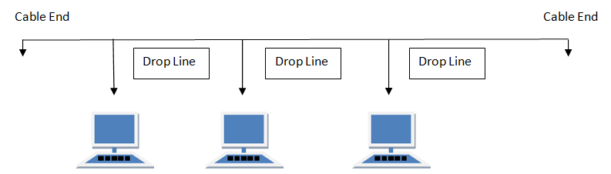

#### Features of Bus Topology

1. It transmits data only in one direction.
2. Every device is connected to a single cable

#### Advantages of Bus Topology

1. It is cost effective.
2. Cable required is least compared to other network topology.
3. Used in small networks.
4. It is easy to understand.
5. Easy to expand joining two cables together.

#### Disadvantages of Bus Topology

1. Cables fails then whole network fails.
2. If network traffic is heavy or nodes are more the performance of the network decreases.
3. Cable has a limited length.
4. It is slower than the ring topology.

**RING Topology**

It is called ring topology because it forms a ring as each computer is connected to another computer, with the last one connected to the first. Exactly two neighbours for each device.

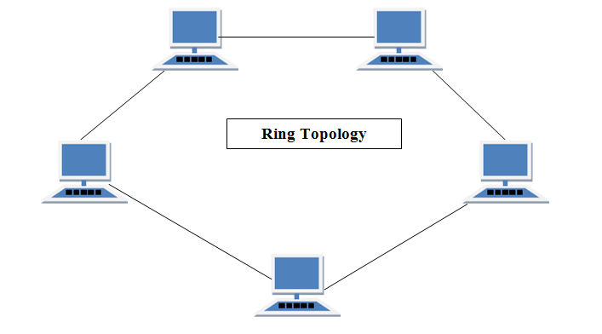

#### Features of Ring Topology

1. A number of repeaters are used for Ring topology with large number of nodes, because if someone wants to send some data to the last node in the ring topology with 100 nodes, then the data will have to pass through 99 nodes to reach the 100th node. Hence to prevent data loss repeaters are used in the network.
2. The transmission is unidirectional, but it can be made bidirectional by having 2 connections between each Network Node, it is called **Dual Ring Topology**.
3. In Dual Ring Topology, two ring networks are formed, and data flow is in opposite direction in them. Also, if one ring fails, the second ring can act as a backup, to keep the network up.
4. Data is transferred in a sequential manner that is bit by bit. Data transmitted, has to pass through each node of the network, till the destination node.

#### Advantages of Ring Topology

1. Transmitting network is not affected by high traffic or by adding more nodes, as only the nodes having tokens can transmit data.
2. Cheap to install and expand

#### Disadvantages of Ring Topology

1. Troubleshooting is difficult in ring topology.
2. Adding or deleting the computers disturbs the network activity.
3. Failure of one computer disturbs the whole network.

**STAR Topology**

In this type of topology all the computers are connected to a single hub through a cable. This hub is the central node and all others nodes are connected to the central node.

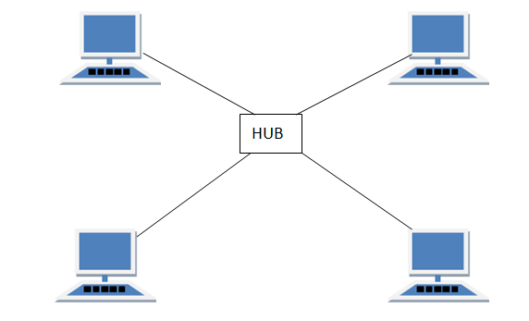

#### Features of Star Topology

1. Every node has its own dedicated connection to the hub.
2. Hub acts as a repeater for data flow.
3. Can be used with twisted pair, Optical Fibre or coaxial cable.

#### Advantages of Star Topology

1. Fast performance with few nodes and low network traffic.
2. Hub can be upgraded easily.
3. Easy to troubleshoot.
4. Easy to setup and modify.
5. Only that node is affected which has failed, rest of the nodes can work smoothly.

#### Disadvantages of Star Topology

1. Cost of installation is high.
2. Expensive to use.
3. If the hub fails then the whole network is stopped because all the nodes depend on the hub.
4. Performance is based on the hub that is it depends on its capacity

## MESH Topology

It is a point-to-point connection to other nodes or devices. All the network nodes are connected to each other. Mesh has n(n-1)/2 physical channels to link n devices.

There are two techniques to transmit data over the Mesh topology, they are :

1. Routing
2. Flooding

### MESH Topology: Routing

In routing, the nodes have a routing logic, as per the network requirements. Like routing logic to direct the data to reach the destination using the shortest distance. Or, routing logic which has information about the broken links, and it avoids those node etc. We can even have routing logic, to re-configure the failed nodes.

### MESH Topology: Flooding

In flooding, the same data is transmitted to all the network nodes, hence no routing logic is required. The network is robust, and the its very unlikely to lose the data. But it leads to unwanted load over the network.

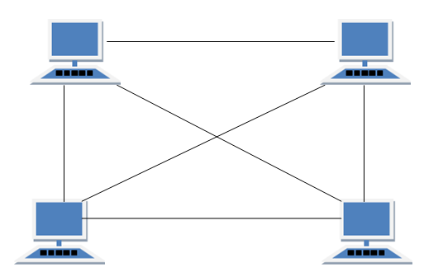

#### Types of Mesh Topology

1. **Partial Mesh Topology :**In this topology some of the systems are connected in the same fashion as mesh topology but some devices are only connected to two or three devices.
2. **Full Mesh Topology :**Each and every nodes or devices are connected to each other.

#### Features of Mesh Topology

1. Fully connected.
2. Robust.
3. Not flexible.

#### Advantages of Mesh Topology

1. Each connection can carry its own data load.
2. It is robust.
3. Fault is diagnosed easily.
4. Provides security and privacy.

#### Disadvantages of Mesh Topology

1. Installation and configuration is difficult.
2. Cabling cost is more.
3. Bulk wiring is required.

## TREE Topology

It has a root node and all other nodes are connected to it forming a hierarchy. It is also called hierarchical topology. It should at least have three levels to the hierarchy.

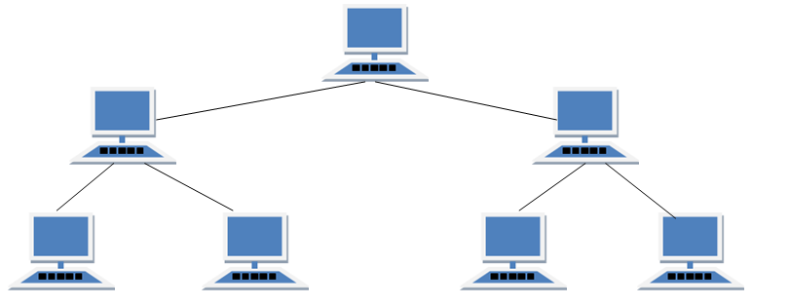

#### Features of Tree Topology

1. Ideal if workstations are located in groups.
2. Used in Wide Area Network.

#### Advantages of Tree Topology

1. Extension of bus and star topologies.
2. Expansion of nodes is possible and easy.
3. Easily managed and maintained.
4. Error detection is easily done.

#### Disadvantages of Tree Topology

1. Heavily cabled.
2. Costly.
3. If more nodes are added maintenance is difficult.
4. Central hub fails, network fails.

## HYBRID Topology

It is two different types of topologies which is a mixture of two or more topologies. For example if in an office in one department ring topology is used and in another star topology is used, connecting these topologies will result in Hybrid Topology (ring topology and star topology).

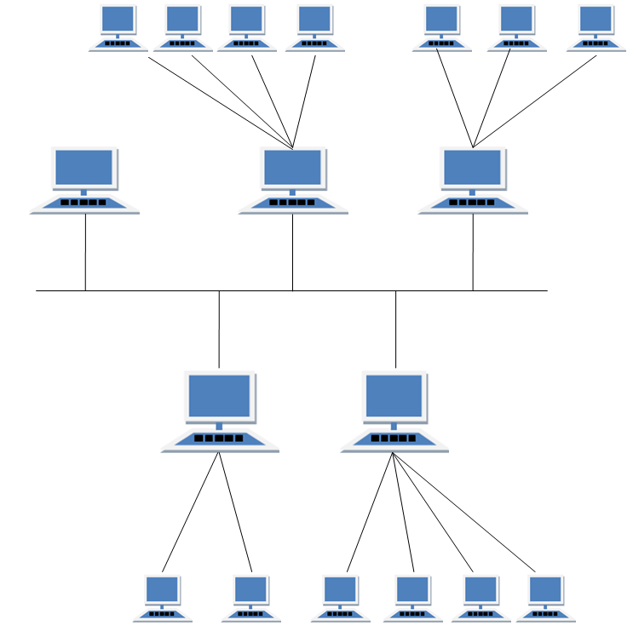

#### Features of Hybrid Topology

1. It is a combination of two or topologies
2. Inherits the advantages and disadvantages of the topologies included

#### Advantages of Hybrid Topology

1. Reliable as Error detecting and trouble shooting is easy.
2. Effective.
3. Scalable as size can be increased easily.
4. Flexible.

#### Disadvantages of Hybrid Topology

1. Complex in design.
2. Costly.

Modem:

A modemis a hardware device that allows a computer to send and receive data over a telephone line or a cable or satellite connection. In the case of transmission over an analog telephone line, which was once the most popular way to access the internet, the modem converts data between analog and digital formats in real time for two-way network communication. In the case of the high-speed digital modems popular today, the signal is much simpler and doesn't require the analog-to-digital conversion.

[**The 9 Best Cable Modems of 2019**](https://www.lifewire.com/best-cable-modems-to-buy-4082523)

### History of Modems

The first devices called modems converted digital data for transmission over analog telephone lines. The speed of these modems was measured in baud (a unit of measurement named after Emile Baudot), although as computer technology developed, these measures were converted into [bits per second](https://www.lifewire.com/bits-per-second-kbps-mbps-gbps-818122). The first commercial modems supported a speed of 110 bps and were used by the U.S. Department of Defense, news services, and some large businesses.

Modems gradually became familiar to consumers in the late 1970s through the 1980s as public message boards and news services like CompuServe were built on early internet infrastructure. Then, with the explosion of the World Wide Web in the mid and late 1990s, dial-up modems emerged as the primary form of internet access in many households around the world.

### Dial-Up Modems

Modems used on [dial-up networks](https://www.lifewire.com/definition-of-dial-up-817779) convert data between the analog form used on telephone lines and the digital form used on computers. An external dial-up modem plugs into a computer at one end and a telephone line on the other end. In the past, some computer makers integrated internal dial-up modems into the computer.

Modern dial-up network modems transmit data at a maximum rate of 56,000 bits per second. However, the inherent limitations of public telephone networks often limit modem data rates to 33.6 Kbps or lower.

When you connect to a network through a dial-up modem, the modem relays through a speaker the distinctive handshaking sounds between your device and the remote modem. Because the connection process and data patterns are similar each time, hearing the sound pattern helps you verify whether the connection process is working.

### Broadband Modems

A [broadband modem](https://www.lifewire.com/definition-of-broadband-modem-817451) like those used for DSL or cable internet access uses advanced signaling techniques to achieve dramatically higher network speeds than earlier-generation dial-up modems. [Broadband modems](https://www.lifewire.com/type-of-broadband-modem-ethernet-usb-817447) are often referred to as high-speed modems. [Cellular modems](https://www.lifewire.com/networking-cell-phones-and-wireless-modems-817461) are a type of digital modem that establishes internet connectivity between a mobile device and a [cell phone network](https://www.lifewire.com/how-fast-is-a-cell-phone-modem-818317).

The word modem is a mashup of the term modulation/demodulation, which is the technical term for the conversion between digital and analog signals.

External broadband modems plug into a home [broadband router](https://www.lifewire.com/what-is-a-broadband-router-816301) or other home [gateway](https://www.lifewire.com/definition-of-gateway-817891) device on one end and the external internet interface such as a cable line on the other. The router or gateway directs the signal to all the devices in the business or home as needed. Some broadband routers include an integrated modem as a single hardware unit.

Many broadband internet providers supply suitable modem hardware to their customers at no charge or for a monthly fee. However, standard modems can be purchased through retail outlets.

Modem is short for "Modulator / Demodulator." It is a [hardware](https://techterms.com/definition/hardware) component that allows a [computer](https://techterms.com/definition/computer) or other device, such as a [router](https://techterms.com/definition/router) or [switch](https://techterms.com/definition/switch), to connect to the Internet. It converts or "modulates" an [analog](https://techterms.com/definition/analog)signal from a telephone or cable wire to a [digital](https://techterms.com/definition/digital) signal that a computer can recognize. Similarly, it converts outgoing digital data from a computer or other device to an analog signal.

The first modems were "[dial-up](https://techterms.com/definition/dialup)," meaning they had to dial a phone number to connect to an [ISP](https://techterms.com/definition/isp). These modems operated over standard analog phone lines and used the same frequencies as telephone calls, which limited their maximum [data transfer rate](https://techterms.com/definition/datatransferrate) to 56 [Kbps](https://techterms.com/definition/kbps). Dial-up modems also required full use of the local telephone line, meaning voice calls would interrupt the Internet connection.

Modern modems are typically [DSL](https://techterms.com/definition/dsl) or [cable modems](https://techterms.com/definition/cablemodem), which are considered "[broadband](https://techterms.com/definition/broadband)" devices. DSL modems operate over standard telephone lines, but use a wider [frequency](https://techterms.com/definition/frequency)range. This allows for higher data transfer rates than dial-up modems and enables them to not interfere with phone calls. Cable modems send and receive data over standard cable television lines, which are typically [coaxial cables](https://techterms.com/definition/coaxial_cable). Most modern cable modems support DOCSIS (Data Over Cable Service Interface Specification), which provides an efficient way of transmitting TV, cable Internet, and digital phone signals over the same cable line.

**NOTE:** Since a modem converts analog signals to digital and vice versa, it may be considered an [ADC](https://techterms.com/definition/adc) or [DAC](https://techterms.com/definition/dac). Modems are not needed for [fiber optic](https://techterms.com/definition/fiber_optic_cable) connections because the signals are transmitted digitally from beginning to end.

# Different Networking Devices And Hardware Types — Hub, Switch, Router, Modem, Bridge, Repeater

***Short Bytes:*** Different networking devices have different roles to play in a computer network. These network devices also work at different segments of a computer network performing different works. In our new series after network topology, we talk about different networking devices like a switch, router, hub, bridge etc.

Computer networking devices are known by different names such as networking devices, networking hardware, network equipment etc. However, all of the names mean the same but have got different purposes. After covering different topics on network topologies and their advantages and disadvantages, we are here once again with a series on the network devices.

Before we talk more about the networking devices, here are a few topics you might want to take a look at that we covered under network topology section:

* [Daisy chaining in computer networks](http://fossbytes.com/network-topology-daisy-chain/)
* [Different network topologies](http://fossbytes.com/what-is-network-topology-and-types-of-network-topology/)
* [Tree topology](http://fossbytes.com/tree-topology-advantage-disadvantage/)
* [Mesh Topology](http://fossbytes.com/what-is-mesh-topology-advantages-and-disadvantages-of-mesh-topology/)
* [Star Topology](http://fossbytes.com/star-topology-advantages-disadvantages-star-topology/)
* [Ring Topology](http://fossbytes.com/what-is-ring-topology-advantages-and-disadvantages-of-ring-topology/)
* [Bus topology](http://fossbytes.com/what-is-bus-topology-and-what-are-its-types/)

If we take a look at the different devices, they work at different layers of the computer networks. Different layers of a computer network are like different zones of a computer network with specified works, also called as 'network protocols'.

**For example:**  
A LAN cable has got the purpose of connecting a computer to the local area network, a Wi-Fi router has got the purpose of sending and receiving data between you and your internet connection. Similarly, we can think of other network devices with different purposes to serve.

## **Different networking devices:**

### **Network Hub:**

Network Hub is a networking device which is used to connect multiple network hosts. A network hub is also used to do data transfer. The data is transferred in terms of packets on a computer network. So when a host sends a data packet to a network hub, the hub copies the data packet to all of its ports connected to. Like this, all the ports know about the data and the port for whom the packet is intended, claims the packet.

However, because of its working mechanism, a hub is not so secure and safe. Moreover, copying the data packets on all the interfaces or ports makes it slower and more congested which led to the use of network switch.

### **Network Switch:**

Like a hub, a switch also works at the layer of LAN (Local Area Network) but you can say that a switch is more intelligent than a hub. While hub just does the work of data forwarding, a switch does 'filter and forwarding' which is a more intelligent way of dealing with the data packets.

So, when a packet is received at one of the interfaces of the switch, it filters the packet and sends only to the interface of the intended receiver. For this purpose, a switch also maintains a CAM (Content Addressable Memory) table and has its own system configuration and memory. CAM table is also called as forwarding table or forwarding information base (FIB).

##### **Also Read:**[**Difference Between Tethering & Hotspot: Which One Is More Secure?**](https://fossbytes.com/difference-tethering-hotspot/)

### **Modem:**

A Modem is somewhat a more interesting network device in our daily life. So if you have noticed around, you get an internet connection through a wire (there are different types of wires) to your house. This wire is used to carry our internet data outside to the internet world.

However, our computer generates binary data or digital data in forms of 1s and 0s and on the other hand, a wire carries an analog signal and that's where a modem comes in.

A modem stands for (**Mo**dulator+**De**modulator). That means it modulates and demodulates the signal between the digital data of a computer and the analog signal of a telephone line.

### **Network Router:**

A router is a network device which is responsible for routing traffic from one to another network. These two networks could be a private company network to a public network. You can think of a router as a traffic police who directs different network traffic to different directions.

### **Bridge:**

If a router connects two different types of networks, then a bridge connects two subnetworks as a part of the same network. You can think of two different labs or two different floors connected by a bridge.

### **Repeater:**

A repeater is an electronic device that amplifies the signal it receives. In other terms, you can think of repeater as a device which receives a signal and retransmits it at a higher level or higher power so that the signal can cover longer distances.

For example, inside a college campus, the hostels might be far away from the main college where the ISP line comes in. If the college authority wants to pull a wire in between the hostels and main campus, they will have to use repeaters if the distance is much because different types of cables have limitations in terms of the distances they can carry the data for.

When these network devices take a particular configurational shape on a network, their configuration gets a particular name and the whole formation is called [Network topology](http://fossbytes.com/what-is-network-topology-and-types-of-network-topology/). In certain circumstances when we add some more network devices to a network topology, its called[Daisy chaining](http://fossbytes.com/network-topology-daisy-chain/).

Network Devices (Hub, Repeater, Bridge, Switch, Router, Gateways and Brouter)

**1. Repeater** – A repeater operates at the physical layer. Its job is to regenerate the signal over the same network before the signal becomes too weak or corrupted so as to extend the length to which the signal can be transmitted over the same network. An important point to be noted about repeaters is that they do not amplify the signal. When the signal becomes weak, they copy the signal bit by bit and regenerate it at the original strength. It is a 2 port device.

**2. Hub** –  A hub is basically a multiport repeater. A hub connects multiple wires coming from different branches, for example, the connector in star topology which connects different stations. Hubs cannot filter data, so data packets are sent to all connected devices.  In other words, [collision domain](https://en.wikipedia.org/wiki/Collision_domain) of all hosts connected through Hub remains one.  Also, they do not have intelligence to find out best path for data packets which leads to inefficiencies and wastage.

**Types of Hub**

* **Active Hub :-**These are the hubs which have their own power supply and can clean , boost and relay the signal along the network. It serves both as a repeater as well as wiring center. These are used to extend maximum distance between nodes.
* **Passive Hub :-**These are the hubs which collect wiring from nodes and power supply from active hub. These hubs relay signals onto the network without cleaning and boosting them and can’t be used to extend distance between nodes.

**3. Bridge** – A bridge operates at data link layer. A bridge is a repeater, with add on functionality of filtering content by reading the MAC addresses of source and destination. It is also used for interconnecting two LANs working on the same protocol. It has a single input and single output port, thus making it a 2 port device.

**Types of Bridges**

* **Transparent Bridges :-**These are the bridge in which the stations are completely unaware of the  
  bridge’s existence i.e. whether or not a bridge is added or deleted from the network , reconfiguration of  
  the stations is unnecessary. These bridges makes use of two processes i.e. bridge forwarding and bridge learning.
* **Source Routing Bridges :-**In these bridges, routing operation is performed by source station and the frame specifies which route to follow. The hot can discover frame by sending a specical frame called discovery frame, which spreads through the entire network using all possible paths to destination.

**4. Switch** – A switch is a multi port bridge with a buffer and a design that can boost its efficiency(large number of  ports imply less traffic) and performance. Switch is data link layer device. Switch can perform error checking before forwarding data, that makes it very efficient as it does not forward packets that have errors and  forward good packets selectively to correct port only.  In other words, switch divides collision domain of hosts, but [broadcast domain](https://en.wikipedia.org/wiki/Broadcast_domain) remains same.

**5. Routers** – A router is a device like a switch that routes data packets based on their IP addresses. Router is mainly a Network Layer device. Routers normally connect LANs and WANs together and have a dynamically updating routing table based on which they make decisions on routing the data packets. Router divide broadcast domains of hosts connected through it.

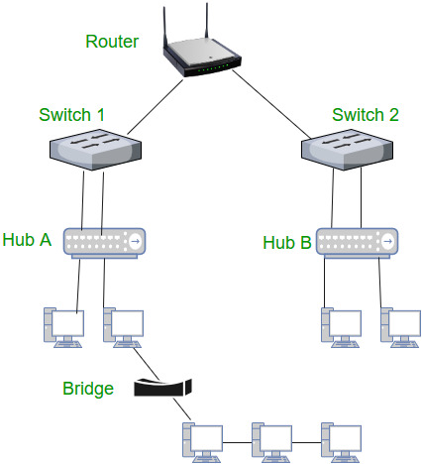

**6. Gateway** – A gateway, as the name suggests, is a passage to connect two networks together that may work upon different networking models. They basically works as the messenger agents that take data from one system, interpret it, and transfer it to another system. Gateways are also called protocol converters and can operate at any network layer. Gateways are generally more complex than switch or router.

**7. Brouter** – It is also known as bridging router is a device which combines features of both bridge and router. It can work either at data link layer or at network layer. Working as router, it is capable of routing packets across networks and working as bridge, it is capable of filtering local area network traffic.